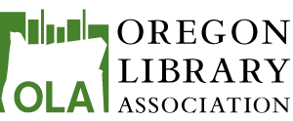

PO Box 3067 • La Grande OR 97850

OLA Leads

Task Force Members: Pierina Parise, Amy Stanforth, Jennifer Snoek-Brown, Gary Sharp, Candice Watkins

The OLA Scholarship Taskforce members will present its scholarship work one last time to the board. Expected action: The taskforce suggests that a new taskforce build upon its work to incorporate the concerns and ideas from the board that have arisen from recent discussions of OLA Leads.

In June, taskforce members secured $5,000 from the Oregon Community Foundation (OCF) as seed money for its OLA Leads pilot year. The proposal was discussed at the retreat and questions arose from the board. It was determined to bring the discussion back to the August board meeting. Three taskforce members – Perri Parise, Gary Sharp, and Amy Stanforth – will be at the board meeting to present their vision and answer questions.

The $25,000 sitting in the HAS MLIS Scholarship Fund. OCF has recommended against investing this money in an endowment-type fund as the interest that it generates would be very low and the main investment of $25,000 would not be accessible after investment. OCF suggests that we consult its advisors for alternative ways to use this $25,000 to generate revenue. Perhaps OLA’s Finance & Investment Committee could also look at alternatives.

For a complete overview of the OLA Leads program, see the OLA Leads Planning Document.

